Step 1 : Create a folder and add it to the workspace
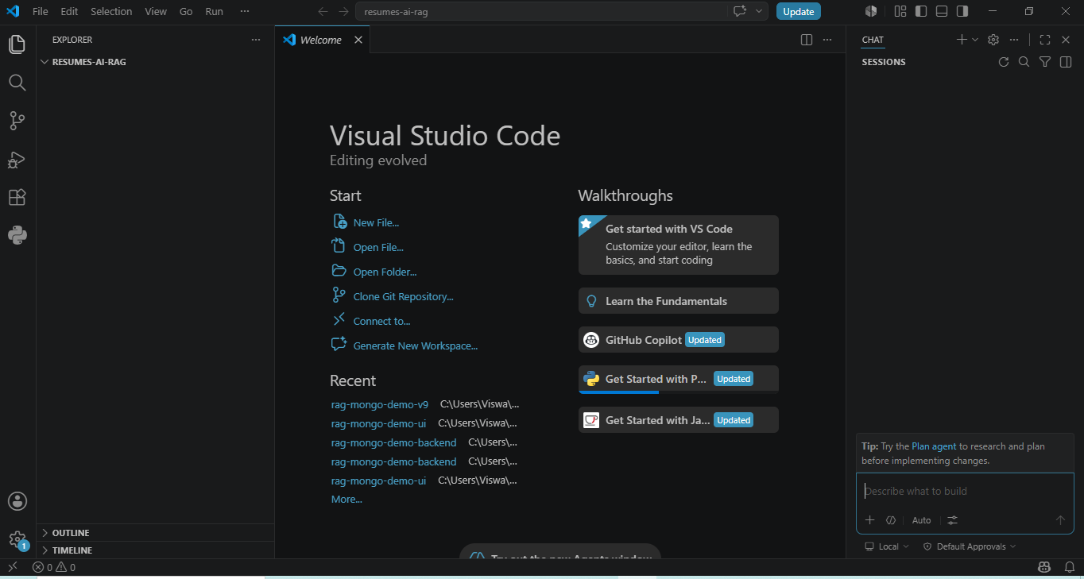
Step 2 : Add Architecture.md file to this folder
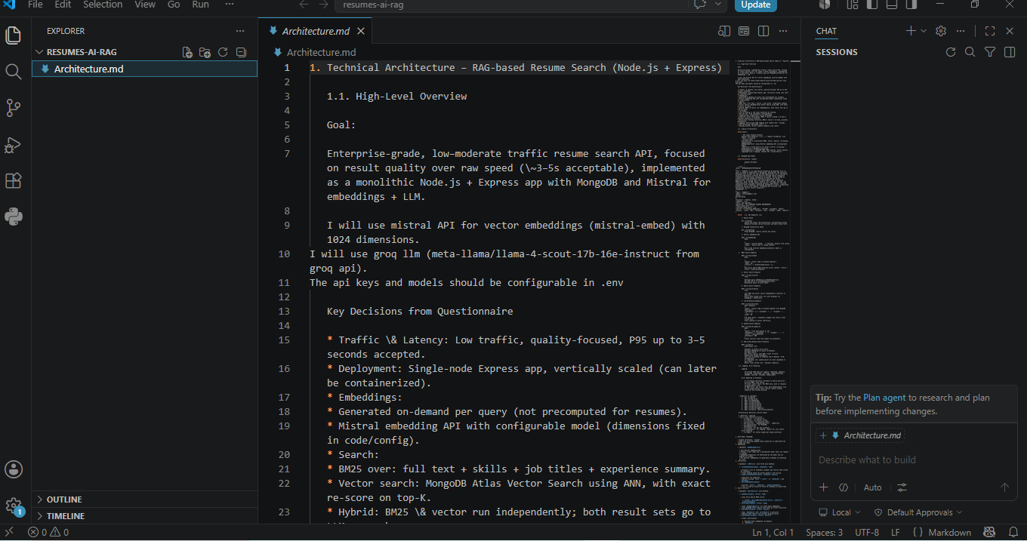
Step 3 : co-pilot chat
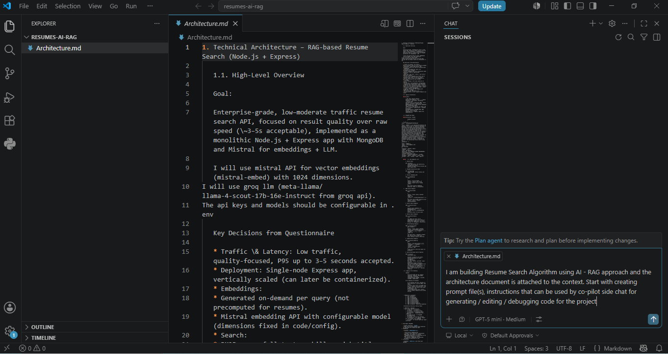
Co-pilot created content :
**Plan — next steps**
- Provide a set of prompt/instruction templates for Copilot-side chat to generate, edit, and debug the project.
- Include: a system prompt, developer instructions, task templates, and LLM prompt templates for rerank/summarize/metadata.
- You can copy these into repo files (I won't modify files unless you ask).

**Files to create (suggested)**
- `copilot-prompt.md`: System prompt for the side-chat assistant.
- `copilot-instructions.md`: Developer-level rules & workflow for code changes.
- `task-templates.md`: Reusable user prompts for common tasks.
- `prompts/rerank-prompt.txt`: LLM reranking prompt template.
- `prompts/summarize-prompt.txt`: Summarization prompt template.
- `prompts/extract-metadata.txt`: Candidate metadata extraction prompt.

**`copilot-prompt.md` — assistant system prompt (copy into repo)**
You are the repo assistant for a TypeScript Node.js + Express project implementing a RAG-based resume search API. Objectives: produce correct, minimal, well-tested code that follows the project's layered architecture (src/app.ts, src/server.ts, src/routes, src/services, src/repositories, src/middleware, src/types). Priorities: correctness, readability, tests, small diffs, minimal surface changes. Constraints: TypeScript, Node v18+, MongoDB, Mistral embedding + LLM, environment via `.env`. Follow these rules on every request:

- Start with a 1–3 step implementation plan before coding.
- Ask clarifying questions if any ambiguity could affect the design.
- When proposing code edits, show the exact files & concise patch (diff or file contents) and explain why.
- Keep changes focused to relevant files; do not change unrelated code.
- Provide unit tests for new logic and show how to run them.
- Use `npm` / `pnpm` commands consistently; include `package.json` changes if required.
- Do not include secrets or real API keys; use `process.env` and `.env.example`.
- Use structured JSON for API responses and structured logs.
- Return TypeScript types for public surfaces.
- When debugging, show failing test output or errors, explain root cause, and propose minimal fix.
- Keep responses concise and actionable.

**`copilot-instructions.md` — developer workflow & conventions**
- Branching: create small-focused branches; name `feature/<short>-<ticket>` or `fix/<short>`.
- Commits: 1 logical change per commit; messages: `feat: add SearchService.bm25Search` or `fix: handle null embedding`.
- Formatting & linting: run `npm run format` and `npm run lint -- --fix` before commit.
- Testing: include unit tests with Jest; run `npm test`. For async DB ops use in-memory MongoDB or mocks.
- TypeScript rules: strict mode on, no `any` in exported module signatures.
- Error handling: central `errorHandler` middleware; endpoints return consistent error shape `{ error: string, code?: string }`.
- Logging: use structured JSON logs; middleware should attach `requestId`.
- Environment: add keys to `.env.example` (e.g., `MISTRAL_API_KEY`, `MISTRAL_EMBED_MODEL`, `GROQ_LLM_MODEL`, `MONGODB_URI`).
- PR description: summary, files changed, how to test manually, related issues.
- Safety: never hardcode API keys or produce PII in examples.

**`task-templates.md` — ask-copilot templates**
Scaffold project
- Prompt: "Create a TypeScript Node.js Express scaffold for `resumes-ai-rag` with `src/app.ts`, `src/server.ts`, routes folder, services, repositories, middleware. Add `package.json` scripts: `build`, `start`, `dev`, `test`, `lint`, `format`. Use ESLint + Prettier + Jest. Show file contents and `package.json`."

Add health endpoints
- Prompt: "Implement `GET /v1/health` and `GET /v1/health/db`. Use `src/routes/health.ts`, `src/services/HealthService`. Add simple Mongo ping in `health/db`. Provide tests."

Implement EmbeddingService + endpoint
- Prompt: "Implement `EmbeddingService` calling the Mistral embedding API (model configurable). Add `POST /v1/embeddings` route and DTOs. Return `{ embedding: number[], model }`. Include tests that mock the HTTP client."

Implement BM25 endpoint
- Prompt: "Implement `SearchService.bm25Search` that runs an Atlas Search BM25 query (simulate via repository method). Add `POST /v1/search/bm25` route. Provide unit tests for service logic and input validation."

Implement Vector search
- Prompt: "Implement `SearchService.vectorSearch` using `EmbeddingService` and `ResumeRepository.vectorSearch`. Add `POST /v1/search/vector`. Include top-K, optional exact re-score."

Implement re-rank + summarize LLM wrappers
- Prompt: "Implement `LLMService.rerankCandidates`, `LLMService.summarizeCandidateFit`, and `LLMService.extractMetadata`. Provide prompt templates and unit tests that mock the LLM client."

Full pipeline
- Prompt: "Implement `POST /v1/search` orchestration: generate embedding, run bm25 & vector, dedupe, rerank topN via `LLMService`, optional summarization. Implement fallback logic and timed structured logging. Add integration tests mocking services."

Debugging template
- Prompt: "I have failing tests with error `<paste error>`. Show likely root causes, the minimal code change, and update unit tests. Provide a patch."

Use placeholders: `{{topK}}`, `{{model}}`, `{{query}}`, `{{candidateList}}`.

**`prompts/rerank-prompt.txt` — LLM reranking template**
You are a concise ranking assistant. Input: a job query and a list of candidate resumes (id + snippet + metadata). Task: score each candidate for relevance to the query and return a sorted JSON array (desc). Scoring rules:
- Score 0–100, higher better.
- Prioritize explicit skill matches, relevant job titles, years of experience, and role seniority.
- Penalize missing required keywords.
- Keep final list length limited to `{{topK}}`.
Output (JSON only):
[
{
"resumeId": "...",
"score": 0.0,
"reason": "one-sentence rationale",
"fitSummary": "1–2 sentence candidate fit summary"
}
]
Sort by `score` descending.

**`prompts/summarize-prompt.txt` — summarization template**
Task: Given a `query` (JD) and a candidate `snippet`, produce a `short` or `detailed` fit summary and a bullet list of matched skills and missing skills. Output JSON:
{
"resumeId": "...",
"style": "short|detailed",
"summary": "...",
"matchedSkills": ["..."],
"missingSkills": ["..."]
}
Follow `maxTokens` if specified.

**`prompts/extract-metadata.txt` — metadata extraction template**
Task: Extract structured metadata from raw resume text. Return JSON:
{
"name": "...",
"email": "...",
"phone": "...",
"location": "...",
"jobTitles": ["..."],
"skills": ["..."],
"totalExperience": 0.0,
"experienceSummary": "..."
}
Be conservative: if a field is not present, return `null` or empty array.

**Quick examples (one-liners)**
- "Implement `SearchService.hybridSearch` to call BM25 and vector in parallel and return both lists."
- "Add request-id middleware that adds `req.requestId` and logs it."

**Next step**
Would you like me to create these files in the repo now (I can generate the exact file contents and patches)?
Step 4 : Generating the prompt files
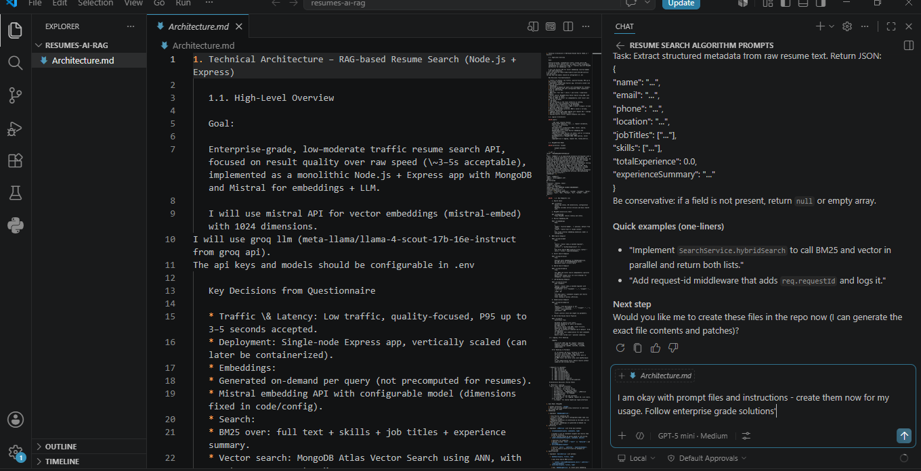
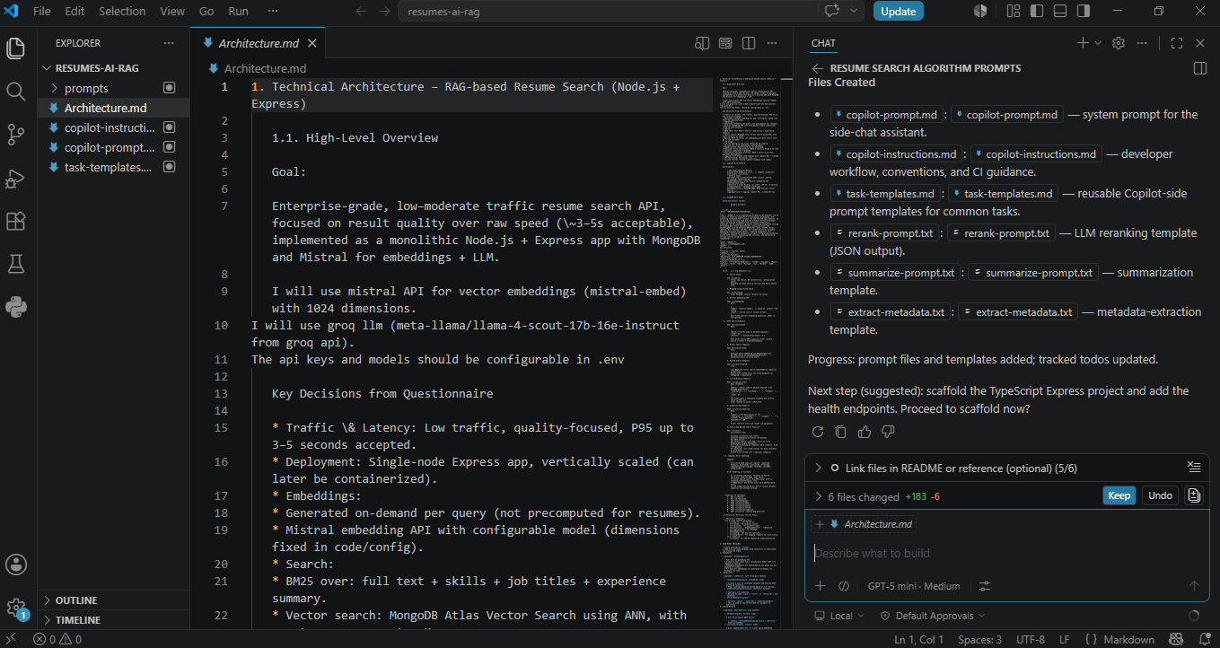
Step 5 : generate the code and update the env file
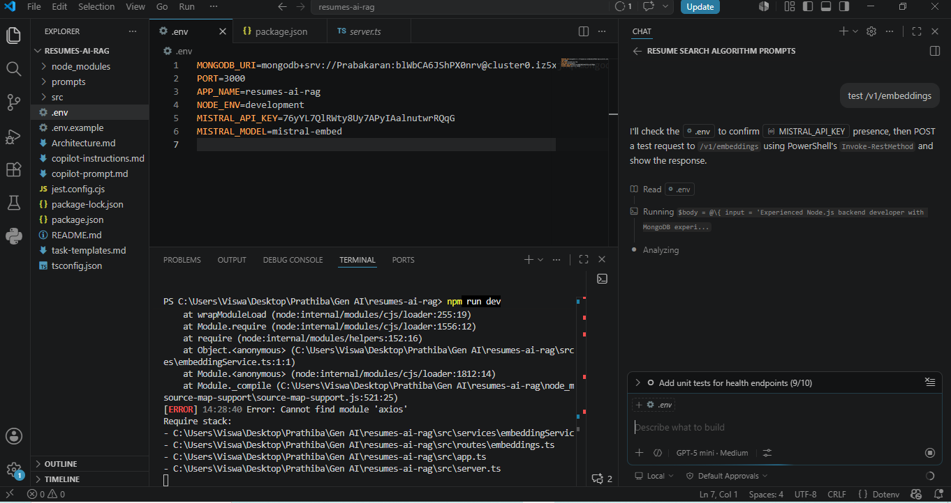
Step 6: Implement Vector Embedding
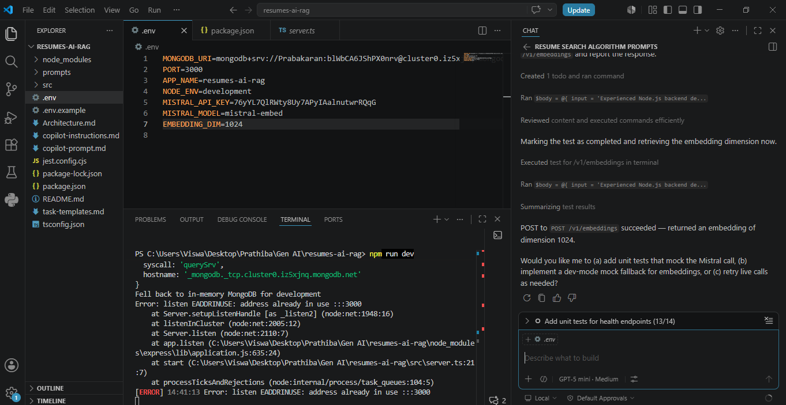
Step 7 : Creating Groq LLM, Atlas Search and Vector search
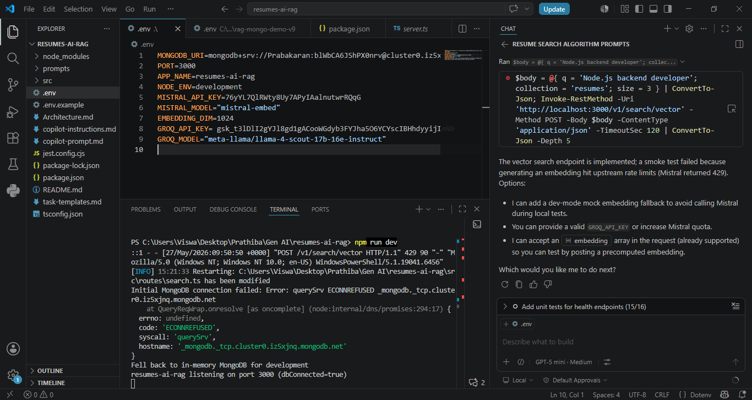

Step 8 : Implement Hybrid Search
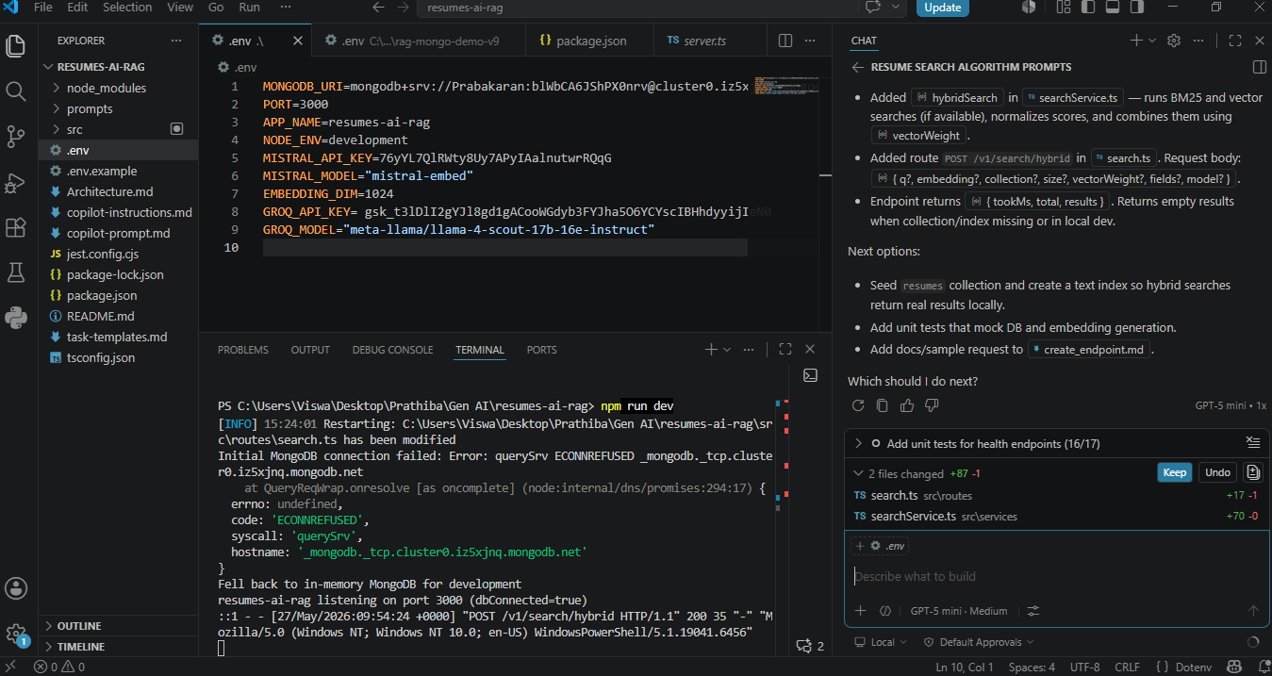
Step 9: LLM Reranking
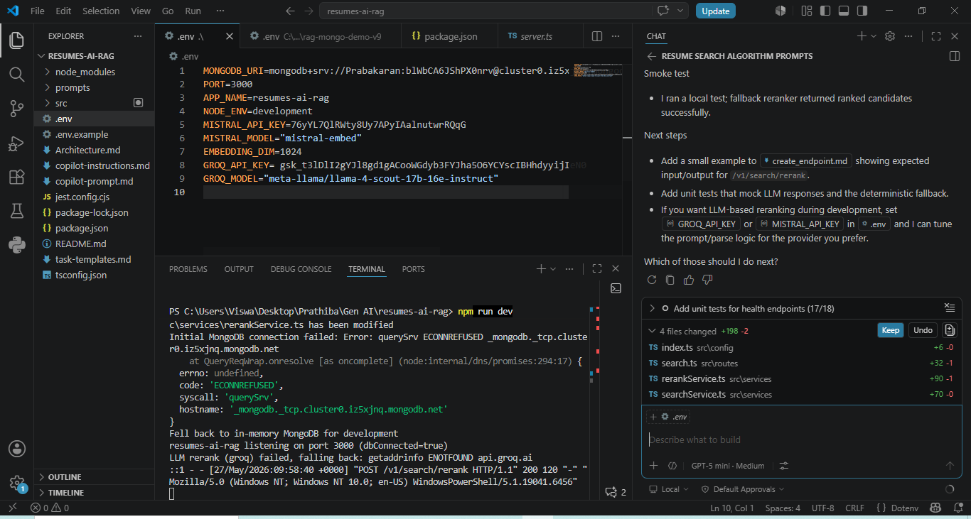

Step 10 : Implement 'End-to-End Resume Search Pipeline config + `/v1/search`.
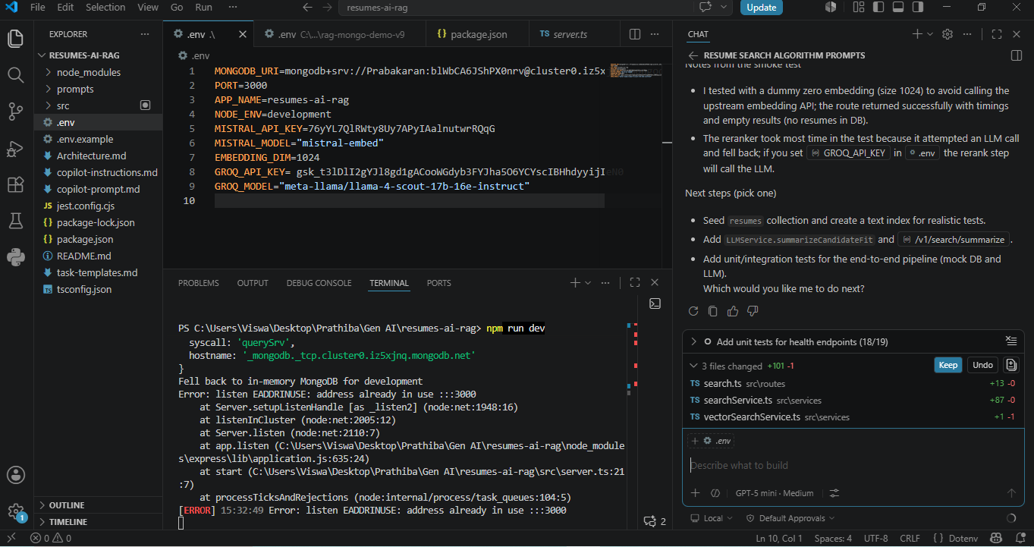
Step 11 : Running the server
